**Assignment no 3**

**1)**

#include<stdio.h>

void main()

{

float a,b,add,sub,mul,div;

printf("enter the first number");

scanf("%f",&a);

printf("enter the second number");

scanf("%f",&b);

add=a+b;

printf("the add is=%f\n",add);

sub=a-b;

printf("the sub is=%f\n",sub);

mul=a*b;

printf("the mul is=%f\n",mul);

div=a/b;

printf("the div is=%f\n",div);

}

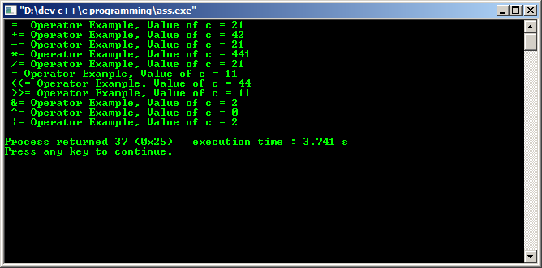

**2)**

#include <stdio.h>

int main()

{

int m=40,n=20;

int o=20,p=30;

if (m>n && m !=0)

{

printf("&& Operator : Both conditions are true\n");

}

if (o>p || p!=20)

{

printf("|| Operator : Only one condition is true\n");

}

}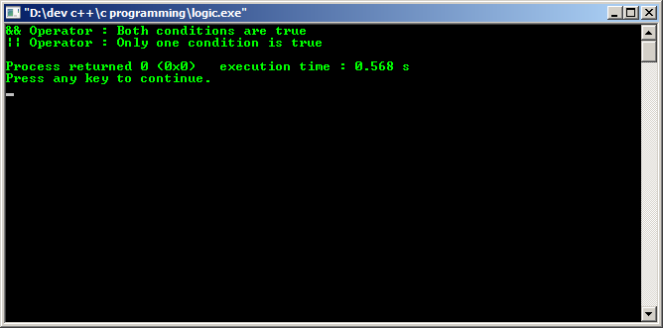

**3)**

#include <stdio.h>

int main()

{

int m=40,n=20;

if (m == n)

{

printf("m and n are equal \n");

}

else

{

printf("m and n are not equal \n");

}

if (m > n)

{

printf("m is greater \n");

}

else

{

printf("n is greater \n");

}

if (m != n)

{

printf("m is not equals to n \n");

}

}

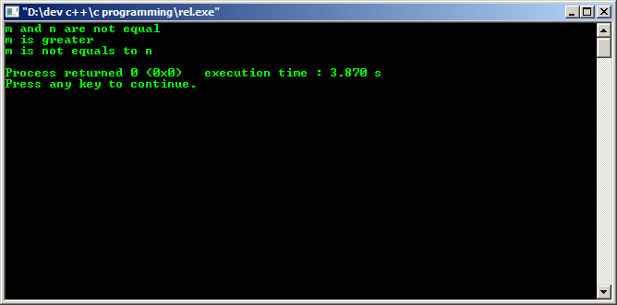

5)

#include<stdio.h>

void main()

{

int a,b,c,d,e,f;

float avg;

printf("enter the marks of 6 subjects : ");

scanf(" %d \t %d \t %d \t %d \t %d \t %d ",&a, &b, &c,&d, &e, &f);

avg = a+b+c+d+e+f/6;

printf("the marks of 6 subjects : %d \t %d \t %d \t %d \t %d \t %d",a, b, c,d, e, f );

printf("\n average is : %f", avg);

}

**6)**

#include<stdio.h>

void main()

{

float pi=3.14,A,C;

int r,rec,l,b,h;

clrscr();

printf("enter the radius of circle");

scanf("%d",&r);

A=3.14*r*r;

printf("area of the circle is %f\n",A);

C=2*3.14*r;

printf("circumference of the circle is %f\n",C);

printf("enter the length, breadth, height of rectangle :");

scanf("%d %d %d",&l, &b,&h);

rec=l*b*h;

printf("area of the rectangle is %d\n",rec);

}

7)

#include<stdio.h>

#include<conio.h>

#define PI 3.142

void main()

{

int r;

float v;

printf("enter the value of r \n");

scanf("%d",&r);

v=(4*PI*r*r*r)/3;

printf("the volume of sphere is %f\n",v);

getch();

}

8)

#include <stdio.h>

int main()

{

float principle, time, rate, SI;

printf("Enter principle (amount): ");

scanf("%f", &principle);

printf("Enter time: ");

scanf("%f", &time);

printf("Enter rate: ");

scanf("%f", &rate);

SI = (principle * time * rate) / 100;

printf("Simple Interest = %f", SI);

return 0;

}